***Class Diagram:***

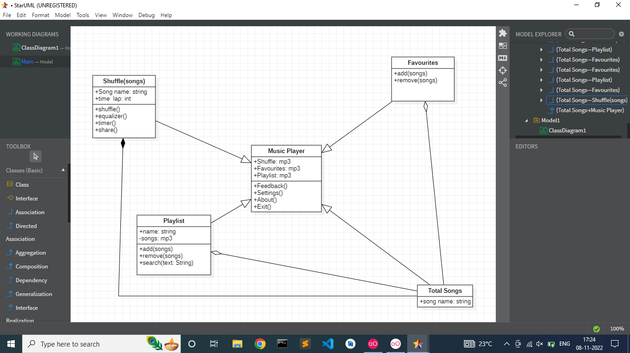

***Activity Diagram for User to Listen to Music***

